**Thanks for your purchase.**

**To begin, open the scene «PopTheLock».**

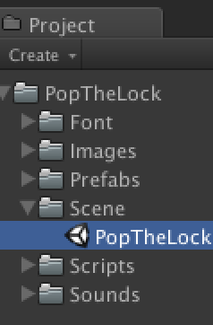

**1 - Sounds:**

All the sounds are here :

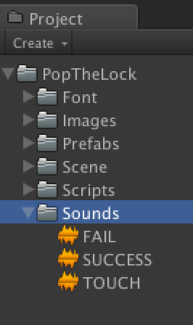

Drop your own sounds here to change them :

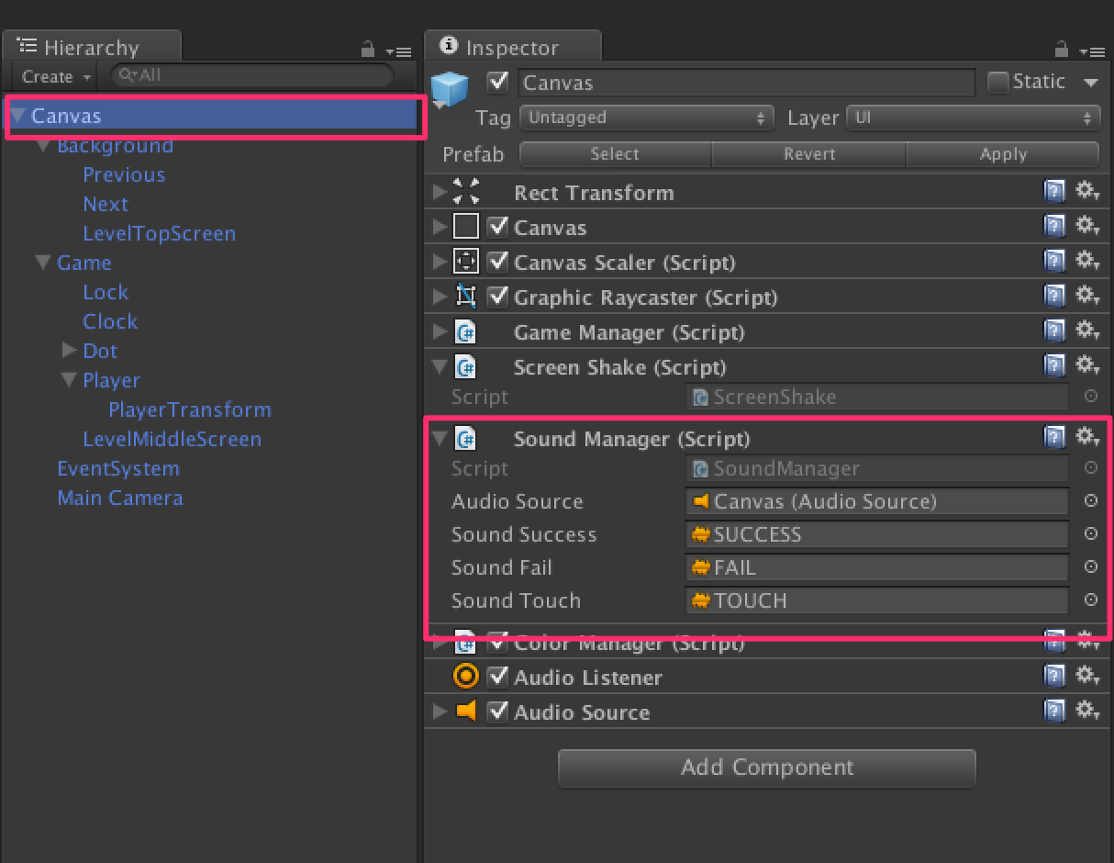

**2 - Images:**

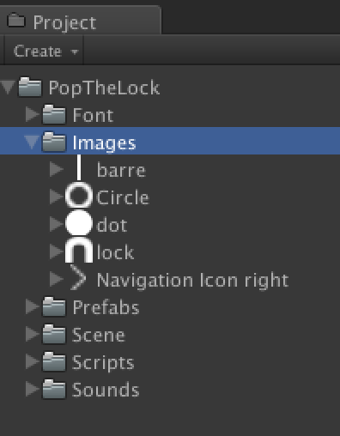

To change them, open the image and do your change. Just don’t modify the size.

**3 - Scripts:**

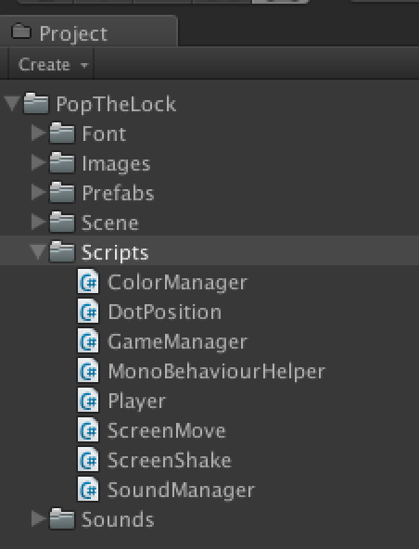

ColorManager.cs :

Attached to the GameObject « Canvas ».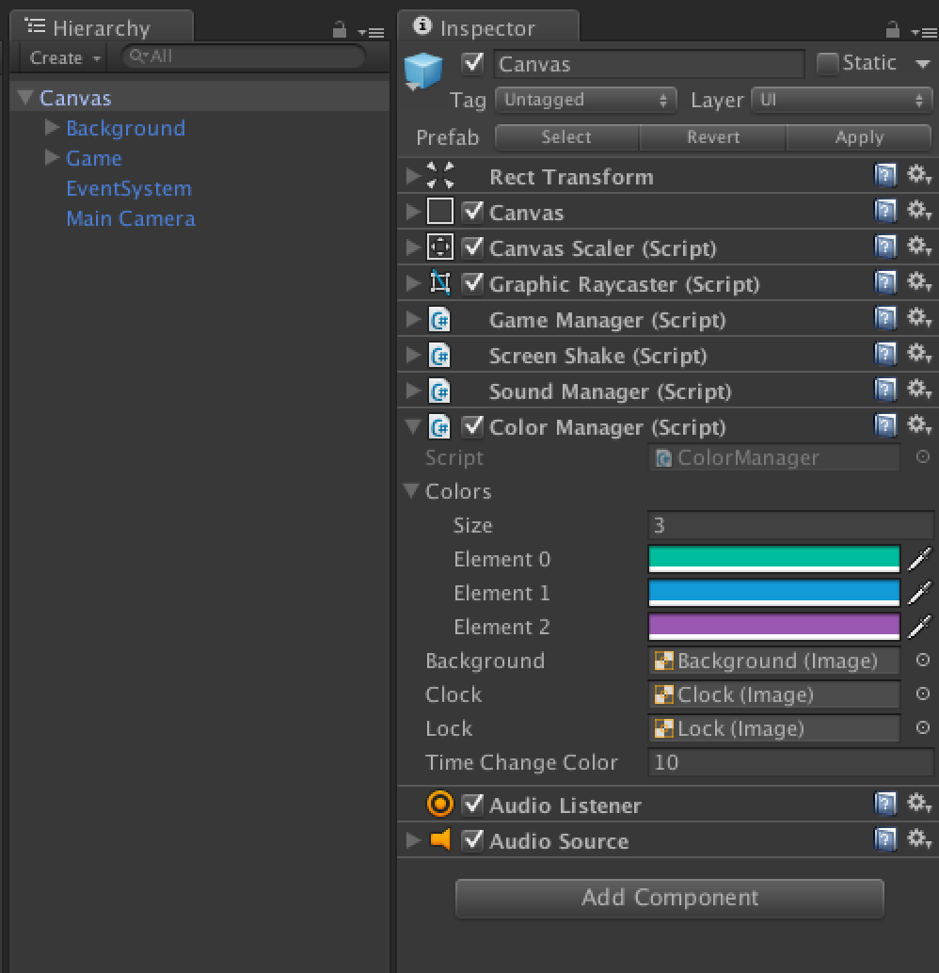

The script change the color of the game.

Change the size if you want to add new colors.

DotPosition.cs :

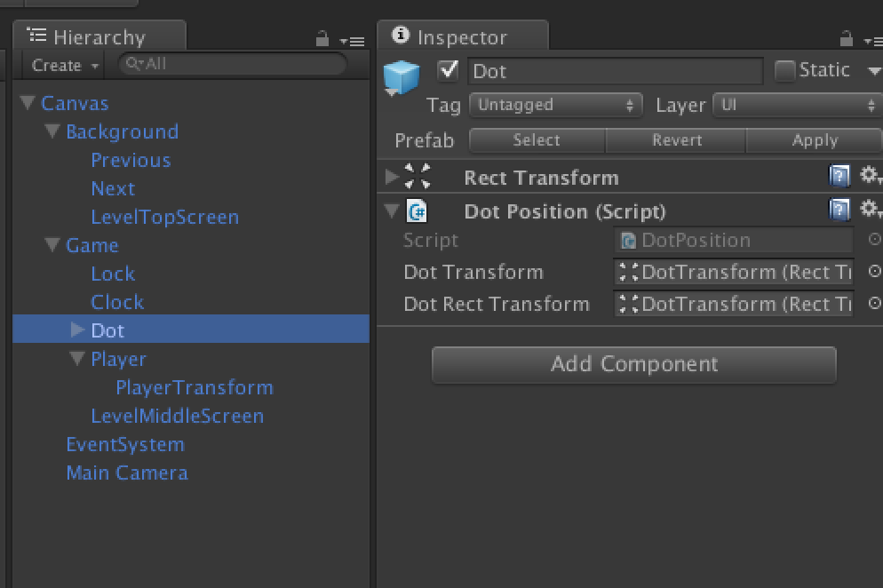

This script managed the position of the dot on the screen.

GameManager.cs :

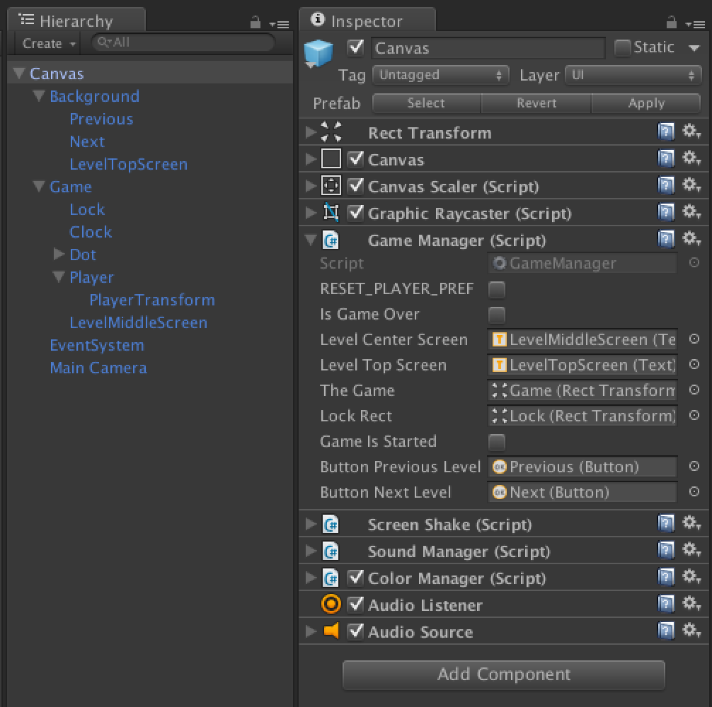

This script managed the states of the game (game over, success, fail…), is responsible of animation transition and save the player progression.

MonoBehaviourHelper.cs :

A simple helper to avoid some duplicate codes.

Player.cs :

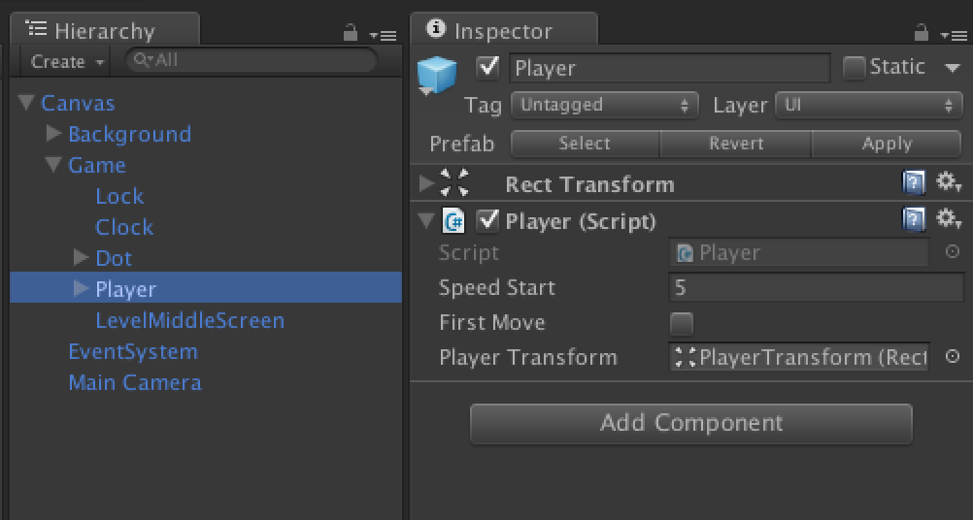

This script managed Input touch or mouse input (for desktop) and move the line.

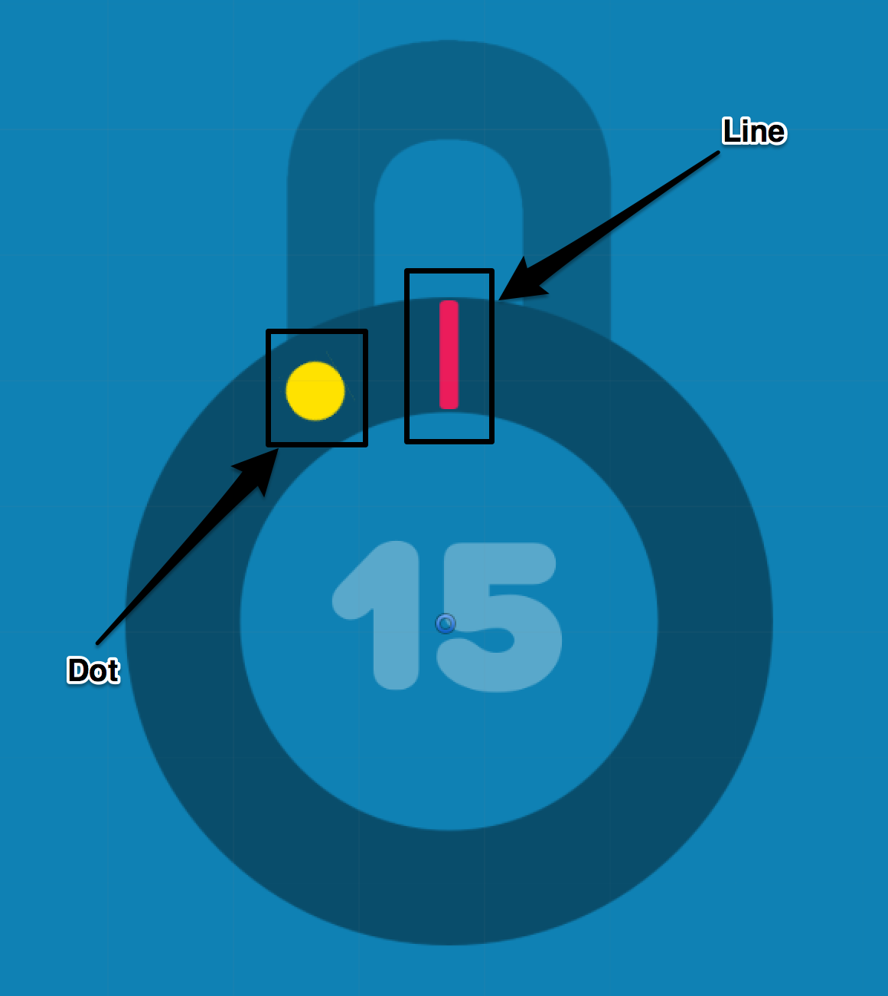

This script tracks the line move and trigger game over if the player touch the screen before the line are in the dot, or if the line pass the dot.

ScreenShake.cs  and ScreenMove.cs:

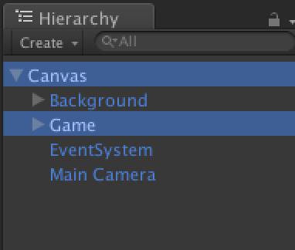

Attached respectively to the GameObject « Canvas » and « Game ». Simple scripts to animate the screen (the shake for game over, the move for success).

SoundManager.cs :

Attached to the GameObject «Canvas ».

The script play the FX during the game.

Please rate my file on the asset store, I’ll appreciate it.

If you need some more help, contact me : [contact@app-advisory.com](mailto:contact@app-advisory.com)